

Practices for Secure Software Report

Table of Contents
Document Revision History 3
Client 3
Instructions 3
Developer 4
1. Algorithm Cipher 4
2. Certificate Generation 4
3. Deploy Cipher 4
4. Secure Communications 4
5. Secondary Testing 4
6. Functional Testing 4
7. Summary 4
8. Industry Standard Best Practices 4

Document Revision History

Version | Date | Author | Comments
1.0 | 4/15/2026 | Matthew Maciak

Client



Instructions

Submit this completed practices for secure software report. Replace the bracketed text with the relevant information. You must document your process for writing secure communications and refactoring code that complies with software security testing protocols.

- Respond to the steps outlined below and include your findings.
- Respond using your own words. You may also choose to include images or supporting materials. If you include them, make certain to insert them in all the relevant locations in the document.
- Refer to the Project Two Guidelines and Rubric for more detailed instructions about each section of the template.

Developer
Matthew Maciak

Algorithm Cipher

Artemis Financial is wanting to modernize their operations with new custom software. One part of that request is to add a secure file verification step. This will be done through the use of a checksum and a hash encryption. Thus allowing for the secure transfer of data within the web application. Due to this being a financial institution one of the main style of attack that will be used. Is a bad actor attack by attempting to gain access to the financial information that is stored. To ensure that only authorized users are accessing this data we will be using the SHA-256 algorithm cipher. This cipher uses a 256-bit hash encryption adding an extremely secure level of security to any software. 256-bits means that the key generated will have 256 characters ranging from A-Z and 0-9. The hash function takes in user/data information and uses a specific key. Will take that data and in essence scramble it up to be transferred over to the recipient. The only way that this hashed data can be read is by de-scrambling it by using the same or a different key depending on the algorithm. This last bit describes symmetric and non-symmetric keys. With a symmetric key the hash function used to encrypt and decrypt the data are the same. Where as with a non-symmetric key there are two different keys used. One for encrypting and the other specifically for decrypting adding another layer of security. The last thing to cover is that with the SHA-256 cipher. The java random number generator is used during the hash function. This creates the non-reverable checksum that will be used by Artemis Financial to ensure the secure communication for data transfers.

Certificate Generation
Insert a screenshot below of the CER file.

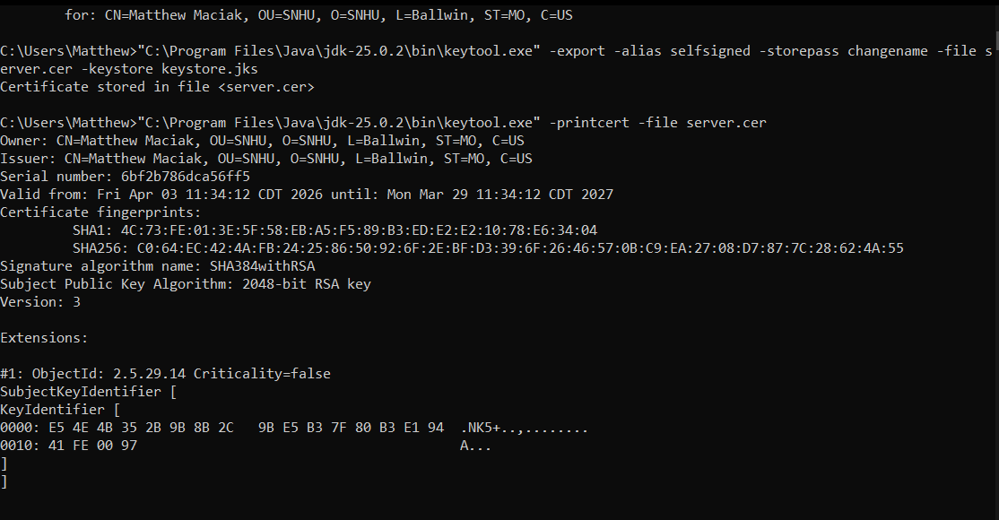

Deploy Cipher
Insert a screenshot below of the checksum verification.

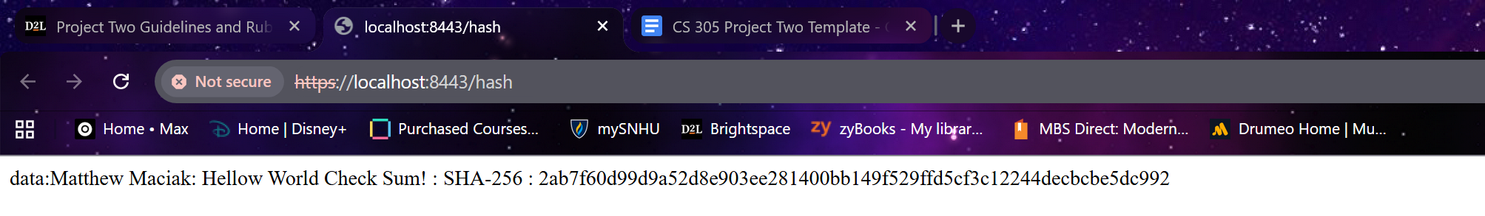

Secure Communications
Insert a screenshot below of the web browser that shows a secure webpage.

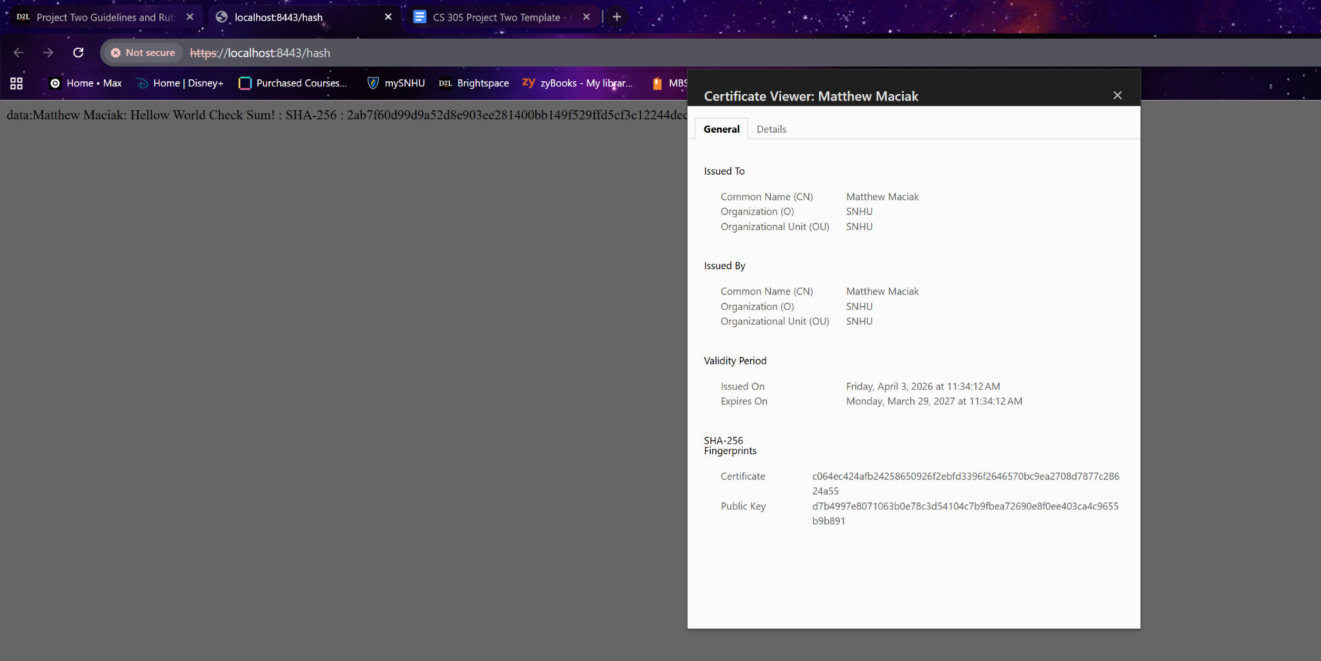

Secondary Testing
Insert screenshots below of the refactored code executed without errors and the dependency-check report.

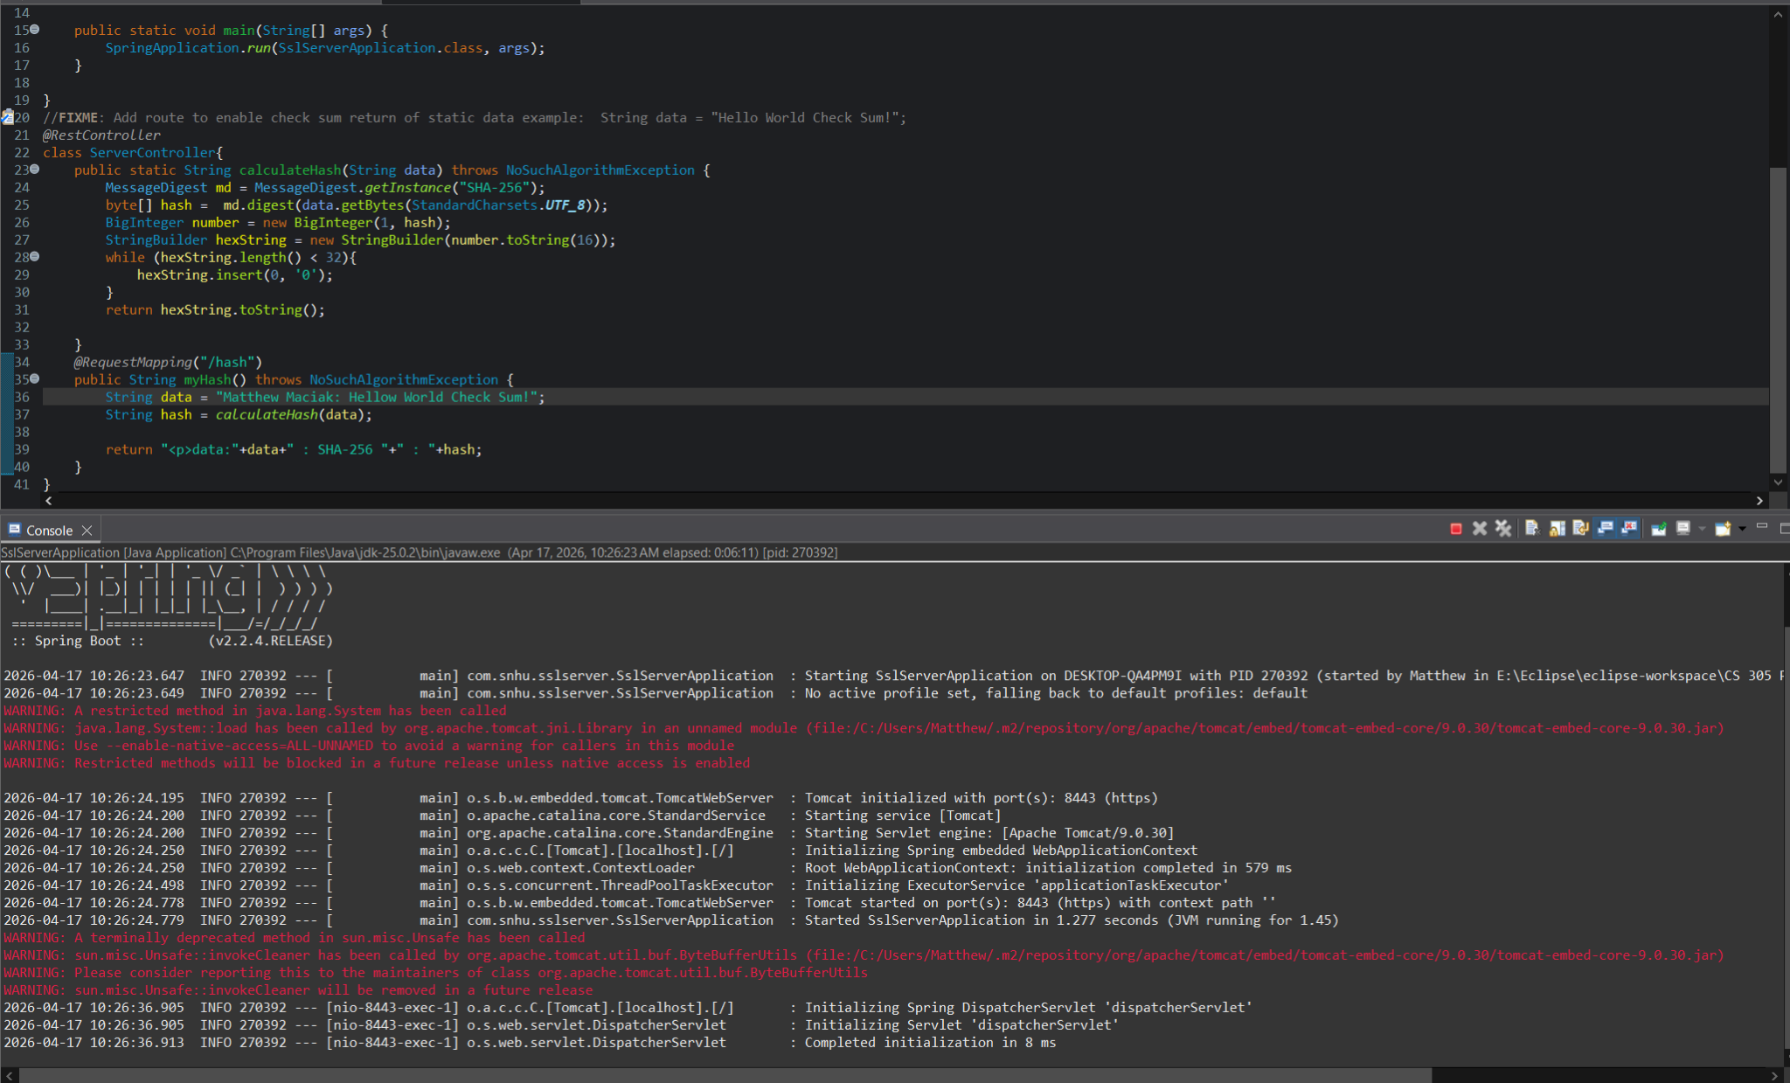
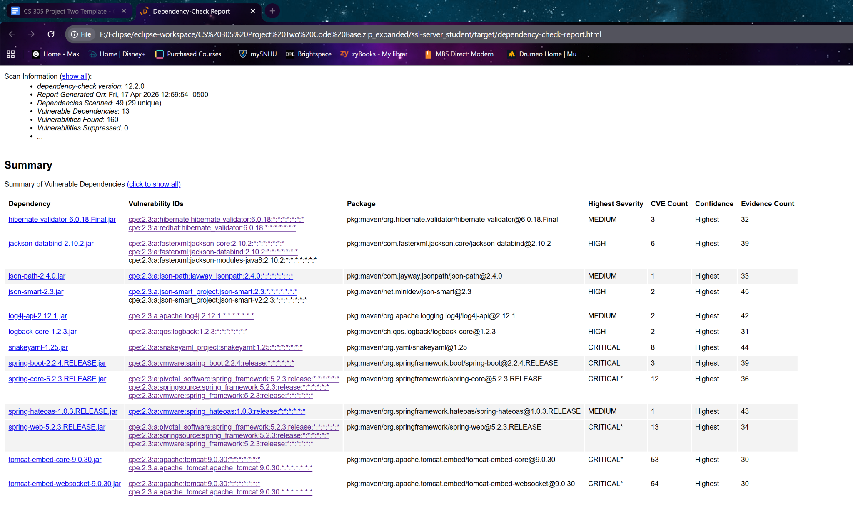

Functional Testing
Insert a screenshot below of the refactored code executed without errors.

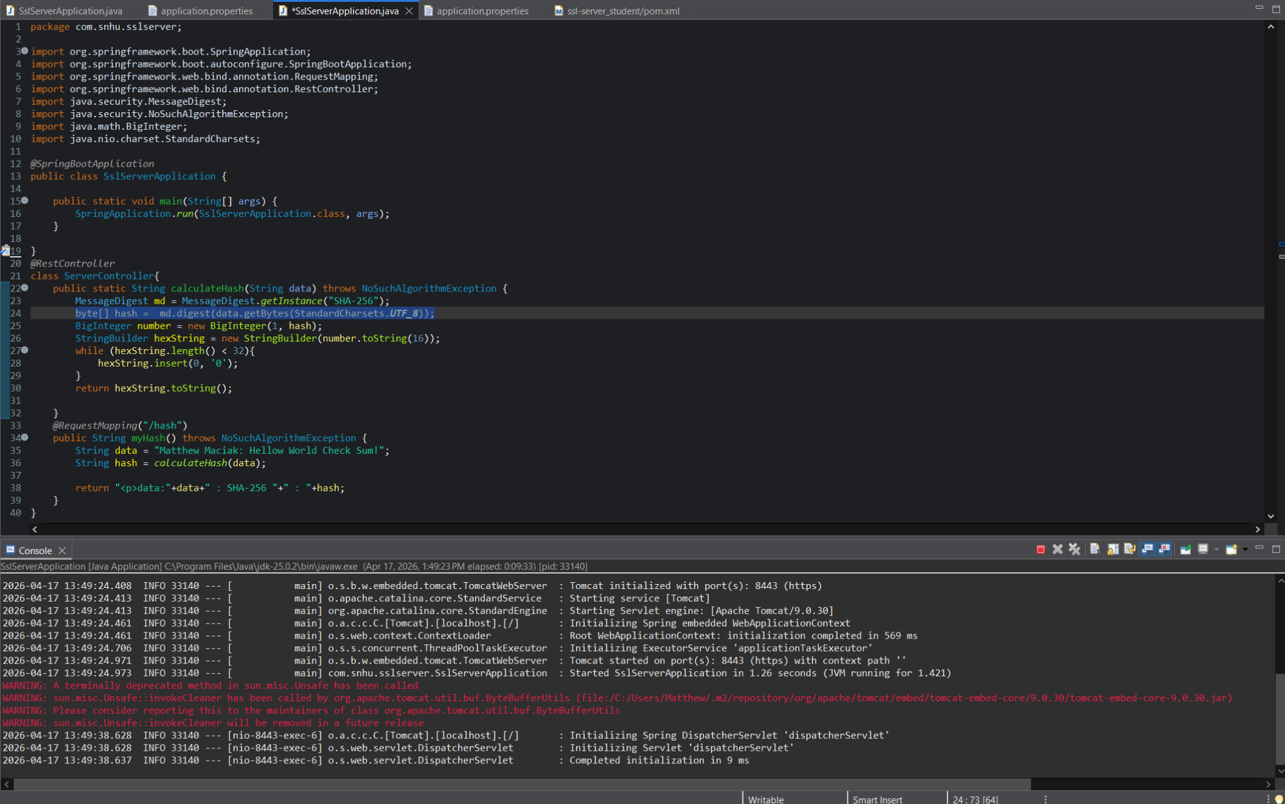

Summary

Refactoring the code from the Artemis Financial software I have successfully added the secured RestController that works as a secure controller for the programs hash RESTful stop. The program works to solve the following problems in the vulnerability assessment process flow diagram. Secure API interactions, encryption use and vulnerabilities, secure error handling, and secure coding practices/patterns. By refactoring the code I have made this software more secure especially through the use of the SHA-256 algorithm cipher, and using up to date coding practices. For future maintenance I recommended monthly or bi-monthly dependency checks. To ensure that all dependencies used are up to date. that no new vulnerabilities have been discovered, and that if there are any they can be resolved.

Industry Standard Best Practices

The software for Artemis Financial has been written in a manner that ensures the maintained security of the program. The added layers of security are in line with current industry standard best practices. B using up to date dependencies and coding standards. Allowing for the secure communication and data transfer within the clients webpage. Applying industry standard best practices allows for secure code to be written from the start and not made secure later on. This keeps security as the highest priority in each of the developers minds. It also means that by applying these practices in place the software will continue to be secure as regular maintenance will be done to it.

